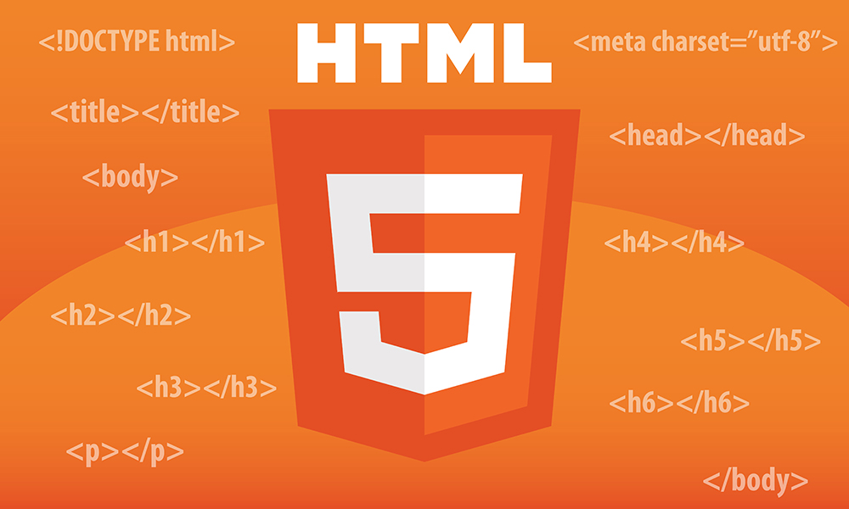  HTML Structure and Core Tags  Learn to structure the web with HTML. | Abstract  HTML is the foundation of web development, used to structure and present content on the web. This module introduces the basics of HTML page structure, core tags, and editors, followed by semantic and non-semantic elements, document structure, layout, text, and formatting tags. Learners will gain a strong foundation for creating well-structured and meaningful web pages.

- Basics of HTML
- HTML stands for Hyper Text Markup Language
- It is used to design the web pages.
- With the help of HTML, you can create a complete website structure.
- HTML is the combination of Hypertext and Markup language. Hypertext defines the link between the web pages and markup language defines the text document within the tag that define the structure of web pages.
- HTML consists of a series of elements
- HTML elements tell the browser how to display the content
HTML Tags: Tags are the starting and ending parts of an HTML element. They begin with < symbol and end with > symbol. Whatever written inside < and > are called tags.

HTML elements: Elements enclose the contents in between the tags. They consist of some kind of structure or expression. It generally consists of a start tag, content and an end tag.
Example: <b>This is the content.</b>
Where, <b> is the starting tag and </b> is the ending tag.
HTML Attributes: It is used to define the character of an HTML element. It always placed in the opening tag of an element. It generally provides additional styling (attribute) to the element.
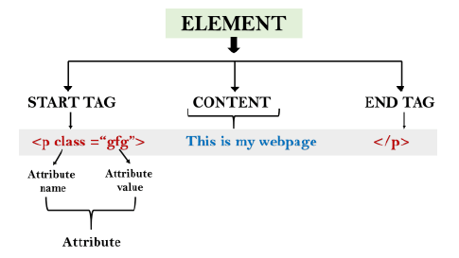

- Page Structure
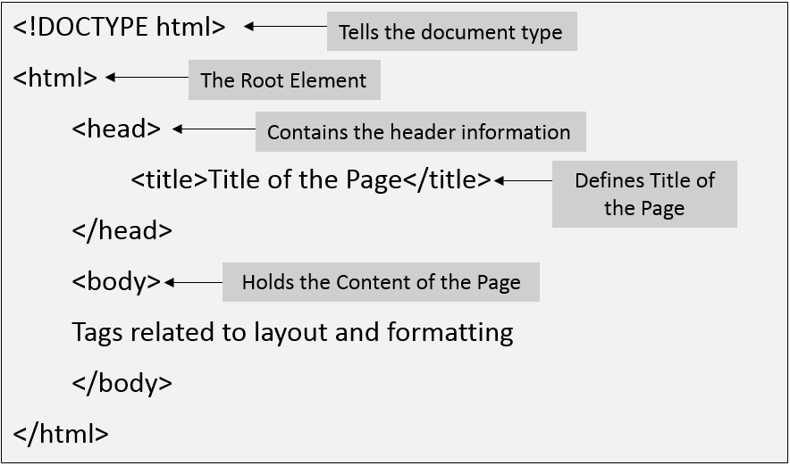

- Building Blocks of HTML
- <!DOCTYPE html> – A doctype or document type declaration is an instruction that tells the web browser about the markup language in which the current page is written. The doctype declaration is not case-sensitive. The declaration is not an HTML tag. It is an "information" to the browser about what document type to expect.
- <html> – This tag is used to define the root element of HTML document. This tag tells the browser that it is an HTML document.
- <head> – This tag is used to define the head portion of the HTML document that contains information related to the document. Elements within the head tag are not visible on the front-end of a webpage.
- <title> -- This element specifies a title for the HTML page (which is shown in the browser's title bar or in the page's tab)
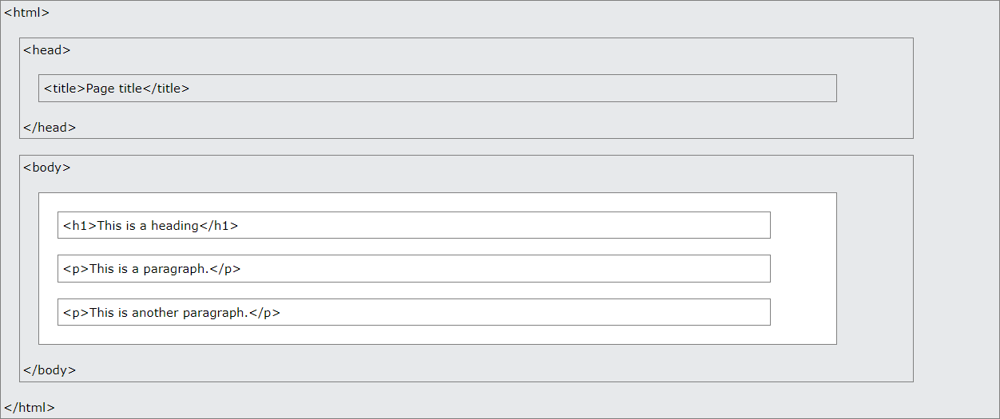
- <body> – The body tag is used to enclose all the visible content of a webpage. In other words, the body content is what the browser will show on the front end. For example, headings, paragraphs, images, hyperlinks, tables, lists, etc.

Editors

Web pages can be created and modified by using editors (sublime,notepad++,vs code etc). However, for learning HTML it is recommended to use simple text editor like Notepad/TextEdit (Mac). It is good way to learn HTML.



First Example:
- Open Notepad

Write HTML
<!DOCTYPE html>
<html>
<head><title>Test</title></head>
<body>
<h1>My First Heading</h1>
<p>My first paragraph.</p>
</body>
</html>

Save the HTML Page
Save the file on your computer. Select File > Save as in the Notepad menu. Name the file "index.html" or “index.htm”

View the HTML Page in Your Browser
Open the saved HTML file in your favorite browser (double click on the file, or right-click - and choose "Open with").
The result will look much like this:
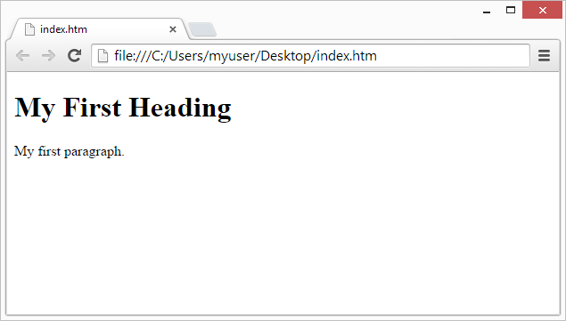
- HTML Comments

- In HTML, comments are written using <!-- and -->.
- The browser ignores everything inside the comment.
- Comments are useful to explain code, organize sections, or hide code for testing
Syntax:
<!-- This is a comment -->
Example:
<!DOCTYPE html>
<html>
<head>
<!-- This is the head section -->
<title>My First Webpage</title>
</head>
<body>
<!-- Main heading -->
<h1>Welcome</h1>
</body>
</html>
- Semantic and Non-Semantic HTML Tags

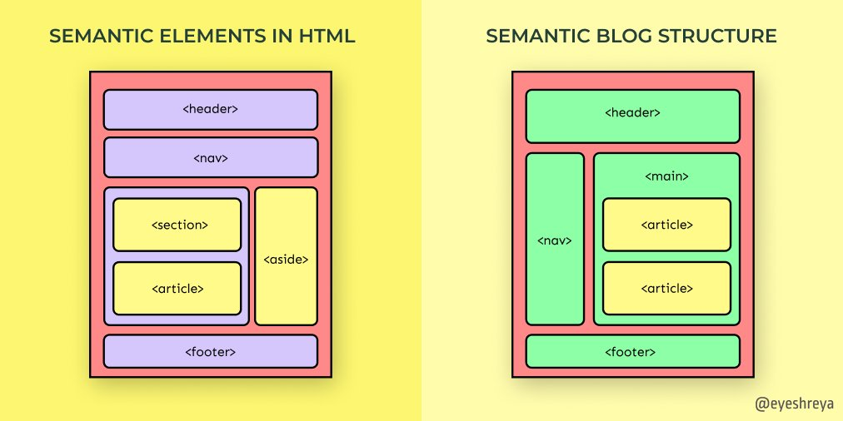
- Semantic Tags → clearly describe their meaning and purpose both to the browser and developer. They make code more readable, SEO-friendly, and accessible.
  - Examples:
    - <header> → defines header section
    - <footer> → defines footer section
    - <article> → represents an independent article
    - <section> → defines a thematic section
    - <aside> → tangential/side content (ads, related links, tips)
    - <nav> → navigation links
    - <main> → main content area
- Non-Semantic Tags → do not describe their meaning. They are used mainly for styling or grouping. They don’t tell what the content is, only how it should look.
  - Examples:
    - <div> → division/container
    - <span> → inline container for text

- Block and Inline elements

Block Elements
Block elements always start on a new line and stretch to the full width of their parent container. They are used to structure the main layout of a page.

<div>, <p>, <h1> to <h6>, <section>, <article>, <aside>, <header>, <footer>, <table>, <ul>, <ol>, <li>, <form>, <main>, <nav>

Inline Elements
Inline elements do not start on a new line. They only take up as much width as their content requires. They are often used for formatting, styling, or embedding small chunks of content within block elements.
<a>, <span>, <b>, <strong>, <i>, <em>, <img>, <br>, <label>, <input>, <textarea>, <select>,<button>, <sub>, <sup>, <abbr>
- Head tags : <link>, <script>, <style>
- <link> → Connects external resources (CSS, favicon).
  - A favicon (short for “favorite icon”) is the small icon that represents a website.
- <script> → Adds JavaScript for interactivity.
- <style> → Adds CSS for styling.
- <meta> → It provides metadata (information about the webpage) for browsers and search engines.

<!DOCTYPE html>
<html>
<head>
<title>Head Tags Example</title>
<!-- Link tag: external CSS file and favicon -->
<link rel="stylesheet" href="styles.css">
<link rel="icon" type="image/png" href="favicon.png">
<!-- Style tag: internal CSS -->
<style>h1 { color: blue; }</style>
<!-- Script tag: external JavaScript -->
<script src="s1.js"></script>
</head>
<body><h1>Head Tags Demonstration</h1></body>
</html>

Meta Tags in HTML
The <meta> tag is placed inside the <head> section of an HTML page.

1. charset
Purpose: Defines character encoding (commonly UTF-8 – Unicode Transformation Format-8).
Real-world scenario: Ensures that special characters, accented letters, emojis, or non-English text display correctly.
<meta charset="UTF-8">
Examples:
- Hindi news website: The Times of India or BBC Hindi
  - Headline: भारत में नई शिक्षा नीति लागू
- Gujarati news website: Divya Bhaskar or Sandesh
  - Headline: અમદાવાદમાં નવાં વર્ષ માટે તહેવારની તૈયારી
Without UTF-8:
Text may appear as random symbols or question marks.
Example:
- Wrong: ������ ������ ���� �����
- Correct with UTF-8: અમદાવાદમાં નવાં વર્ષ માટે તહેવારની તૈયારી

2. viewport
Purpose: Makes a website responsive on mobile devices.
<meta name="viewport" content="width=device-width, initial-scale=1.0">
Example: Flipkart or Myntra: On a mobile phone, the layout adjusts so product images, buttons, and menus fit perfectly, making online shopping easy on smartphones.

3. description
Purpose: Short summary of the page, used by search engines.
<meta name="description" content="Learn the best street food recipes from India including chaat, vada pav, and golgappa.">
Example: When someone searches “Indian street food recipes,” Google may show this description under the page title on Sanjeev Kapoor’s recipe website or Tarla Dalal recipes.

4. keywords
Purpose: List of keywords relevant to the page content.
<meta name="keywords" content="Indian recipes, street food, vada pav, chaat, golgappa">
Example: Helps search engines understand the page topic. For instance, a blog about Indian street food will rank better when users search for “vada pav recipe” or “chaat recipes.”

5. author
Purpose: Indicates the creator of the webpage.
<meta name="author" content="Arjun Mehta">
Example: A food blog post written by Arjun Mehta, an Indian food blogger. Some browsers or CMS platforms may display the author’s name, giving proper credit.

6. http-equiv
Purpose: Provides HTTP header-like info. Can be used for refresh, content type, or caching.
<meta http-equiv="refresh" content="10;url=https://indiatimes.com">
Example: A page on IndiaTimes that says “Thank you for subscribing to our newsletter” and then redirects to the homepage after 10 seconds.
Example:
<head>
<!-- Character encoding for Indian languages -->
<meta charset="UTF-8">
<!-- Responsive design for mobile devices -->
<meta name="viewport" content="width=device-width, initial-scale=1.0">
<!-- Short description for search engines -->
<meta name="description" content="Explore the best Indian street food recipes including chaat, vada pav, pani puri, and more.">
<!-- Relevant keywords -->
<meta name="keywords" content="Indian recipes, street food, vada pav, chaat, pani puri, Mumbai food">
<!-- Author of the webpage -->
<meta name="author" content="Arjun Mehta">
<!-- Page refresh (redirects after 10 seconds) -->
<meta http-equiv="refresh" content="10;url=https://en.wikipedia.org/wiki/Meta_element">
</head>

- TAGS
Category | Tag | Description
Layout & Sectioning Tags | <div> | Generic container, used for grouping elements.
 | <span> | Inline container for styling a small portion of text.
 | <header> | Represents the top section of a webpage or article.
 | <footer> | Bottom section of a webpage (credits, copyright).
 | <main> | Main content of the webpage.
 | <section> | Defines sections in a webpage.
 | <article> | Represents self-contained content (e.g., blog post).
 | <aside> | Sidebar content, not the main focus.
 | <nav> | Navigation links/menu.
Content & Text Tags | <h1> to <h6> | Headings (h1 is largest, h6 is smallest).
 | <p> | Paragraph of text.
 | <pre> | Preformatted text (preserves spaces, line breaks).
 | <br> | Line break.
 | <hr> | Horizontal line (divider).
Hyperlink Tag | <a> | Anchor tag used for hyperlinks.
Text Formatting Tags | <b> | Bold text (visual only).
 | <strong> | Important text (semantic meaning).
 | <i> | Italic text (visual only).
 | <em> | Emphasized text (semantic meaning).
 | <u> | Underlined text.
 | <mark> | Highlighted text.
 | <del> | Deleted/strikethrough text.
 | <ins> | Inserted/underlined text.
 | <sub> | Subscript (below text).
 | <sup> | Superscript (above text).
 | <abbr> | Abbreviation (shows full form on hover).
Example:
<html>
<head>
<title>HTML Tags Example</title>
</head>
<body>
<!-- Layout & Sectioning Tags -->
<header>Website Header</header>
<nav>Navigation Bar</nav>
<main>

<section>
<article>
<h1>Main Heading</h1>
<p>This is a <b>bold</b> word and this is <i>italic</i>.</p>
<p>You can also <strong>highlight importance</strong> or <em>emphasize text</em>.</p>
<p>
Here is <u>underlined</u>, <mark>highlighted</mark>, <del>deleted</del>,
and <ins>inserted</ins> text.
</p>
<p>Water formula: H<sub>2</sub>O and Square: x<sup>2</sup></p>
<p>
<abbr title="HyperText Markup Language">HTML</abbr> is the base of web
pages.
</p>
<pre>
Preformatted text keeps
spaces & line breaks.
</pre>
<p>Line break here<br>Next line</p>
<hr>
<a href="https://example.com" target="_blank">Visit Example.com</a>
</article>
</section>
<aside>Sidebar Information</aside>
</main>
<footer>Website Footer</footer>
</body>
</html>

Output:
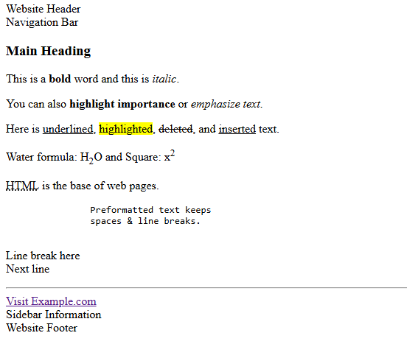

- id and class attributes
- id attribute
- A unique identifier for a single element on a page.
- Used to target that element in CSS or JavaScript.
- Each id must be unique (only one per page).
- class attribute
- A reusable label that can be assigned to multiple elements.
- Used to apply the same styles or behaviors to groups of elements.
Why use them?
- To style elements with CSS.
- To manipulate elements with JavaScript.
- To provide structure and meaning in HTML for easier maintenance and reusability.
In short:
- id = unique identifier (one element).
- class = reusable category (many elements).

- HTML Link: Anchor tag (<a>)
Defines a hyperlink, which is used to link from one page to another. The most important attribute of the <a> element is the href attribute, which indicates the link's destination.

Attributes:
- href: Specifies the URL of the page the link goes to
- target: Specifies where to open the linked document
- name: is used to specify the name for an <a> element. It is used to reference the form data after submitting the form or to reference the element in a JavaScript.

<a href="url" target="_blank | _self" id="a_link">Test</a>
_blank = Opens the linked document in a new window or tab
_self = Opens the linked document in the same frame as it was clicked (this is default)

Example:
<a href=”https://www.example.com” target=”_blank”>Click here</a>
- When rendered in a browser, it would look like this: Click here
- If you click it, it will open https://www.example.com in a new tab.
- When target="_blank" is used, it tells the browser to open the link in a new browser tab or window (depending on browser settings).
- This is helpful when you want to keep the current page open while navigating to another site.

Example: Create a webpage that contains a long block of text and a link at the bottom which, when clicked, scrolls the user back to the top of the page. The solution should demonstrate how to use the id attribute to define an anchor point (<a id="...">) and the href="#..." link to navigate back to that point.
<html>
<body>
<a id="test"></a>
<h1>
<pre>
a
b
c
d
e
f
g
h
i
j
k
l
m
n
o
p
q
r
s
t
u
v
w
x
y
z
a
b
c
d
e
f
g
h
i
j
</pre>
</h1>
<a href="#test">Scroll to top</a>
</body>
</html>

- <a id="test"></a>: A unique identifier used to reference or target elements. It is the preferred method in modern HTML. Using id is more current and widely supported.
- <a href="#test">Scroll to top</a>
This creates a hyperlink that, when clicked, will scroll the user back to the point in the page where the named anchor (<a name="test"></a>) is located. The #test in the href attribute reference.
Note:
name: Used in older versions of HTML for named anchors, but mostly for form elements now. It's deprecated for anchor elements in HTML5.

Media Tags

<img>
- Used to display images.
- Attributes: src (image source), alt (alternative text), width, height.

<figure> and <figcaption>
- <figure> groups media content (like images or videos) with an optional caption.
- <figcaption> provides a caption for the media inside <figure>.

Example: Understand the concept of <img>,<figure>,<figcaption>.

<img src="html.jpg" alt="A beautiful image" width="300" height="200">

<figure>
<img src="html.jpg" alt="A beautiful image" width="300" height="200">
<figcaption>Html Image</figcaption>
</figure>
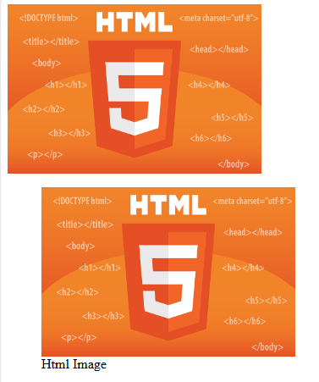
Using <figure> with <img> is useful because it semantically groups an image with its caption, making the content more meaningful and accessible. The <figcaption> inside <figure> provides a clear description or context for the image, which improves accessibility, SEO, and content clarity.
In short: <figure> + <img> = image + optional caption, grouped meaningfully.

Information:

Absolute File Paths
An absolute file path is the full URL to a file:
<img src="https://www.lju.com/images/picture.jpg" alt="css">

Relative File Paths
A relative file path points to a file relative to the current page.
In the following example, the file path points to a file in the images folder located at the root of the current web:
<img src="/images/picture.jpg" alt="css">

<audio>
- Embeds audio files.
- Attributes: controls (show play/pause controls), autoplay, loop, muted.
  - controls → shows play/pause/volume UI.
  - autoplay → tries to start audio automatically.
  - muted → starts muted (browsers allow muted autoplay).
  - loop → plays continuously.
Example:
<audio controls autoplay muted loop>
<source src="1.mp3" type="audio/mpeg">
Your browser does not support the audio element.
</audio>
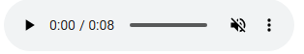
To allow play audio automatically on muted mode
- Open Chrome.
- Go to Settings → Privacy and Security → Site Settings.
- Scroll to Additional content settings → Sound.
- Here you can:
  - Allow all sites to play sound automatically, OR
  - Add specific sites to Allow list (so they can autoplay with sound).

<video>
- Embeds video files.
- Attributes: controls, autoplay, loop, width, height, muted.
Example:
<video autoplay controls muted loop width="700" height="500">
<source src="2.mp4" type="video/mp4" >
Your browser does not support the video element.
</video>



<source>
- Specifies multiple media sources for <audio> or <video> so the browser can choose a supported format.
Example:
<video width="400" controls>
<source src="video.mp4" type="video/mp4">
<source src="video.ogg" type="video/ogg">
</video>

<iframe>
- Embeds another webpage, map, video (like YouTube), pdf etc inside your page.
Attribute | Purpose | Example from your code
src | URL or file path of embedded resource | src="https://www.wikipedia.org"
width | Sets width in pixels | width="600"
height | Sets height in pixels | height="400"
frameborder | Shows/hides border (deprecated) | frameborder="0"
style | Inline CSS (styling) | style="border:0;"
allowfullscreen | Allows fullscreen (mainly for video) | allowfullscreen (YouTube iframe)
loading | Lazy/eager load for performance | loading="lazy" (Google Maps iframe)
title | Accessibility/SEO description | title="YouTube video player"

Example:
<body>
<h1>Iframe Examples</h1>

<!-- 1. Another Webpage -->
<h2>Embed Webpage</h2>
<iframe src="https://www.wikipedia.org" width="600" height="400" frameborder="0"></iframe>

<!-- 2. YouTube Video -->
<h2>Embed YouTube Video</h2>
<iframe width="560" height="315" src="https://www.youtube.com/embed/qz0aGYrrlhU?si=eNLgc597jsbAK9-2" title="YouTube video player" frameborder="0" allowfullscreen></iframe>

<!-- 3. Google Maps -->
<h2>Embed Google Maps</h2>
<iframe src="https://www.google.com/maps/embed?pb=!1m18!1m12!1m3!1d3672.8940065186866!2d72.48528877603572!3d22.990924817507025!2m3!1f0!2f0!3f0!3m2!1i1024!2i768!4f13.1!3m3!1m2!1s0x395e9aee615392b1%3A0x30d4b8160142adf3!2sL%20J%20Institute%20Of%20Management%20Studies!5e0!3m2!1sen!2sin!4v1756790030904!5m2!1sen!2sin" width="600" height="450" style="border:0;" allowfullscreen="" loading="lazy"></iframe>

<!-- 4. PDF Document -->
<h2>Embed PDF</h2>
<iframe src="Chapter 1-Introduction.pdf" width="600" height="500"></iframe>

<!-- 5. Local HTML File -->
<h2>Embed Local Page</h2>
<iframe src="fv.html" width="500" height="300" frameborder="1"></iframe>
</body>

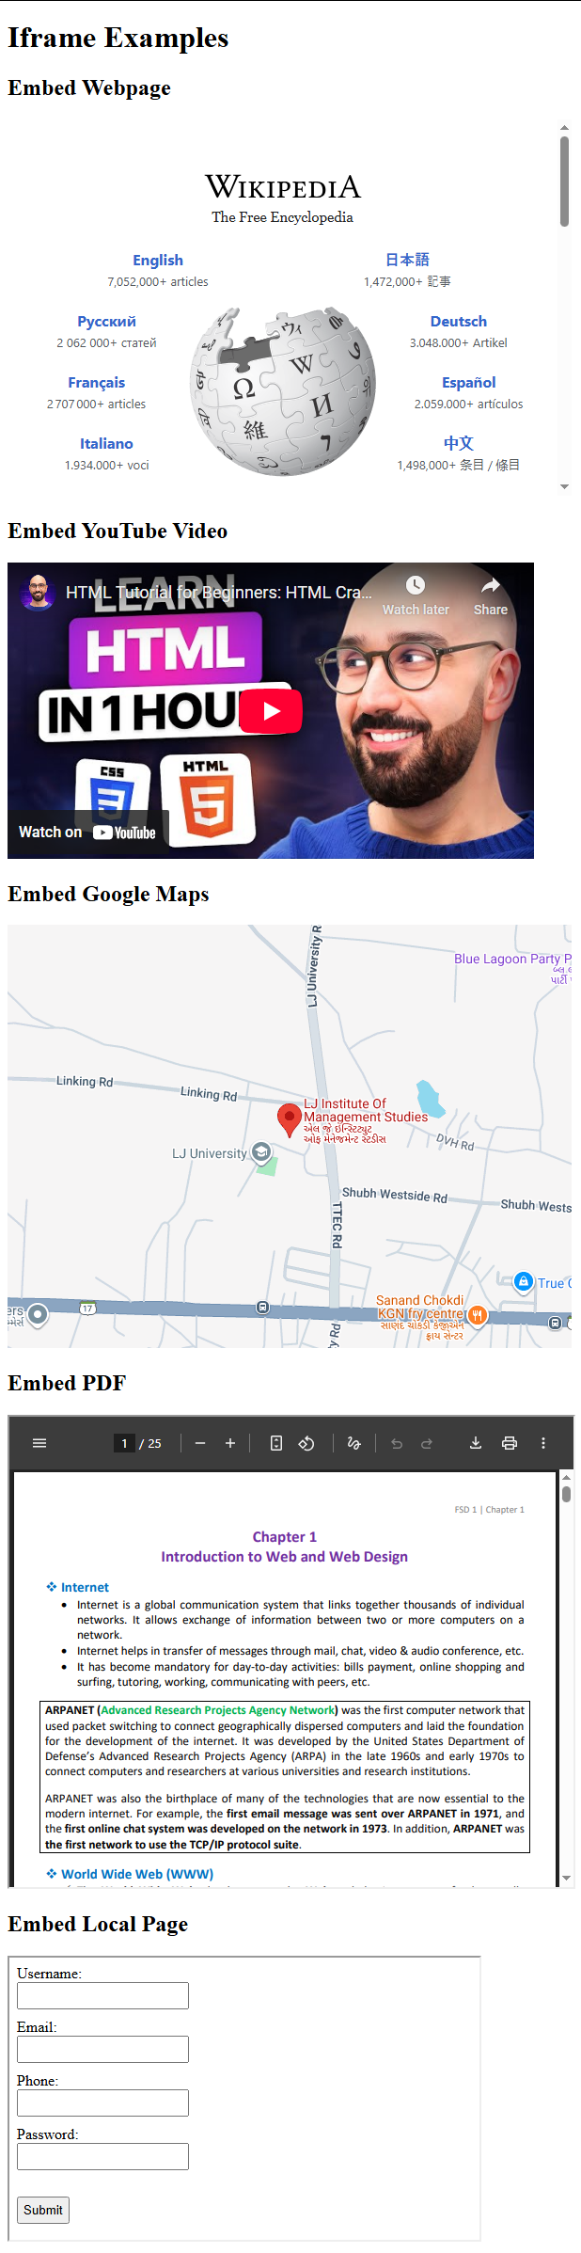
When we open the file directly, it uses file://, which is treated as a local file and doesn't provide a normal web origin to YouTube. Because of this, the YouTube iframe can show Error 153.
With Live Server, the page runs through http://localhost:5500, which gives it a proper web origin, so YouTube can load the video correctly
- HTML Lists:
A list is a record of short pieces of related information or used to display the data or any information on web pages in the ordered or unordered form. For instance, to purchase the items, we need to prepare a list that can either be ordered or unordered list which helps us to organize the data & easy to find the item.

There are two types of lists:
- Unordered list: An unordered list starts with the <ul> tag. Each list item starts with the <li> tag. The list items will be marked with disc (small black circles) by default.

Attribute:
type: type = ”disc/square/circle/none”

<ul>
<li>Test 1</li>
<li>Test 2</li>
<ul type="square">
<li>Test 3</li>
<li>Test 4</li>
</ul>
</ul>
Output:

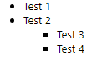

type="disc":
Items are marked with filled circles as bullet points. This is default.
● Item 1
● Item 2
● Item 3
type="square":
Items are marked with squares.
■ Item 1
■ Item 2
■ Item 3
type="circle":
Items are marked with hollow circles.
⚪ Item 1
⚪ Item 2
⚪ Item 3
type="none":
No bullet points are shown for the list items.
Item 1
Item 2
Item 3
- Ordered list: An ordered list starts with the <ol> tag. Each list item starts with the <li> tag. The list items will be marked with numbers by default:

Attribute:
type: type=” 1/ i/ I/ a/ A”
start: Specifies the start value of an ordered list
reversed: Specifies that the list order should be reversed (9,8,7...)
<ol start="5">
<li>Test 1</li>
<li>Test 2</li>
<li>Test 3</li>
<ol type="A">
<li>Test 4</li>
<li>Test 5</li>
<ol reversed type="i">
<li>Test 6</li>
<li>Test 6</li>
</ol>
</ol>
</ol>
Output:

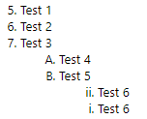

For type ‘a’ 27,28,29.. letters are aa,ab,ac… respectively.

Nested List Example:

<html>
<head><title>Nested List</title></head>
<body>
<ol type="A" start="4">
<li>List1</li>
<li>List2</li>
<ul type="square">
<li>list2.1</li>
<li>list2.2</li>
<ol type="I" reversed >
<li>list 2.2.1</li>
<li>list 2.2.1</li>
<li>list 2.2.1</li>
</ol>
</ul>
<li>List3</li>
<ul type="none">
<li>list 3.1</li>
<li>list 3.2</li>
</ul>
<li>list4</li>
<ol type="a">
<li>list 4.1</li>
<ul type="circle">
<li>list 4.1.1</li>
<li>list 4.1.2</li>
</ul>
<li>list 4.1</li>
</ol>
</ol>
</body>
</html>
